 | United Nations | ECE/TRANS/WP.29/1074/Rev.2
 | Economic and Social Council |  | Distr.: General  3 March 2011  English only
Economic Commission for Europe
Inland Transport Committee
World Forum for Harmonization of Vehicle Regulations
One-hundred-and-fifty-third session
Geneva, 8-10 March 2011
Item 7.1 of the provisional agenda
1997 Agreement (Periodical Technical Inspections) -
Status of the Agreement
Status of the 1997 Agreement and of the Rules annexed to it
Revision 2
Note by the Secretariat*

This document contains information as available to the secretariat, concerning the situation at 4 March 2011. Relevant additional information will be circulated for the other two sessions of the World Forum in 2010 in order to bring this document up to date.
Agreement concerning the adoption of uniform conditions for periodical technical inspections of wheeled vehicles and the reciprocal recognition of such inspections
1. Status of the Agreement
The Agreement entered into force on 27 January 2001 (Depositary Notification C.N.1074.2000.TREATIES-2, dated 30 November 2000).
Correction to Article 11, paragraph g of the Agreement (Depositary Notification C.N.145.2004.TREATIES-2, dated 4 March 2004).
Amendment to Article 12 of the Agreement entered into force on 1 December 2004 (Depositary Notification C.N.892.2004.TREATIES-4, dated 2 September 2004).
Amendments to Articles 1, 2, 12 and to Appendix 2 to the Agreement entered into force on 4 July 2007 (Depositary Notification C.N.405.2007.TREATIES-2, dated 17 April 2007).
2. Status of the Rules annexed to the Agreement
Rule No. 1 entered into force on 4 December 2001 as Addendum 1 to the Agreement (Depositary Notification C.N.1410.2001.TREATIES-3, dated 7 December 2001); document ECE/RCTE/CONF/4/Add.1 has been published on 30 April 2002.
Amendment to Rule No. 1 entered into force on 15 February 2007 (Depositary Notification C.N.216.2007.TREATIES-1, dated 16 February 2007).
3. Contracting Parties to the Agreement (11)
Russian Federation by definitive signing (13 November 1997: Depositary Notification (Reissued) C.N.564.1997.TREATIES-18, dated 19 October 1999); effective 27 January 2001;
Estonia by accession (9 September 1998: Depositary Notification C.N.455.1998.TREATIES-1, dated 23 October 1998); effective 27 January 2001;
Netherlands by signing (13 November 1997) and ratification (5 February 1999: Depositary Notification C.N.52.1999.TREATIES-1, dated 8 February 1999); effective 27 January 2001;
Romania by signing (13 November 1997) and ratification (24 February 1999: fax of OLA,
dated 25 February 1999, Depositary Notification has not been received); effective
27 January 2001;
Hungary by signing (13 November 1997) and ratification (28 November 2000: Depositary Notification C.N.1070.2000.TREATIES-1, dated 30 November 2000); effective
27 January 2001;
Finland by signing (13 November 1997) and ratification (20 April 2001: Depositary Notification C.N.352.2001.TREATIES-1, dated 24 April 2001); effective 19 June 2001;
Bulgaria by accession (11 July 2003: Depositary Notification C.N.738.2003.TREATIES-1, dated 11 July 2003); effective 9 September 2003;
Belarus by accession (2 March 2004: Depositary Notification C.N.203.2004.TREATIES-3, dated 3 March 2004); effective 1 May 2004;
Albania by accession (22 December 2004: Depositary Notification
C.N.1316.2004.TREATIES-4, dated 23 December 2004); effective 20 February 2005;
Ukraine by signing (13 November 1997) and ratification (17 January 2007: Depositary Notification C.N.34.2007.TREATIES-1, dated 17 January 2007); effective 18 March 2007;
Moldova by accession (5 December 2007: Depositary Notification
C.N.1123.2007.TREATIES-2, dated 6 December 2007); effective 3 February 2008. */
4. Signatories Pending Ratification (17)
Austria; Belgium; Cyprus; Czech Republic; Denmark; France; Georgia; Germany; Greece; Ireland; Italy; Portugal; Spain; Sweden; Switzerland; United Kingdom signed at Vienna (13 November 1997: Depositary Notifications C.N.549 to 569.1997.TREATIES-3, dated 17 June 1999);
Slovakia signed at Geneva (29 June 1998: Depositary Notification C.N.870.1998.TREATIES-2,
dated 18 June 1999).
5. Notifications by the Contracting Parties regarding the Administrative Authorities and Technical Services
Finland: Administrative authority responsible for supervising the inspection tests and issuing the International Inspection Certificates, according to para. 6 of Rule 1.
Vehicle Administration Centre (Ajoneuvohallintokeskus)  P.O. Box 120  FIN – 00101 HELSINKI | Tel: (+358) 100-7800

Administrative authority supervising the technical inspection in Aland
Aland Islands Government  Motor Vehicle Bureau  Möckelövägen 58  AX-22120 MARIEHAMN  ALAND | Tel: (+358) 18-525-840  E-mail: registrator@ls.aland.fi

Estonia: Administrative authority
Eesti Riiklik Autoregistrikeskus  Mäepealse 19  EST – 12618 TALLINN | Tel: (+372) 6201-200  Fax: (+372) 6201-201

Romania: Administrative authority
Ministry of Transport, Construction and Tourism  Romanian Automotive Register - RAR  Technical Inspection and Individual  Approval Department  Calea Grivitei 391, sector 1  RO- 010767 BUCAREST | Tel: (+40.21) 224-1537  Fax: (+40.21) 224-1537  E-mail: dobre@rarom.ro

Accredited technical inspection centres

Centre No. | Technical Inspection Centre | Centre No. | Technical Inspection Centre
1 | RAR Alba | 22 | RAR Harghita
2 | RAR Arad | 23 | RAR Hunedoara
3 | RAR Arges | 24 | RAR Ialomita
4 | RAR Bacau | 25 | RAR Iasi
5 | RAR Bihor | 26 | RAR Maramures
6 | RAR Bistrita Nasaud | 27 | RAR Mehedinti
7 | RAR Botosani | 28 | RAR Mures
8 | RAR Brasov | 29 | RAR Neamt
9 | RAR Braila | 30 | RAR Olt
10 | RAR Bucuresti | 31 | RAR Prahova
11 | RAR Buzau | 32 | RAR Satu Mare
12 | RAR Caras Severin | 33 | RAR Salaj
13 | RAR Calarasi | 34 | RAR Sibiu
14 | RAR Cluj | 35 | RAR Suceava
15 | RAR Constanta | 36 | RAR Teleorman
16 | RAR Covasna | 37 | RAR Timis
17 | RAR Dambovita | 38 | RAR Tulcea
18 | RAR Dolj | 39 | RAR Vaslui
19 | RAR Galati | 40 | RAR Valcea
20 | RAR Giurgiu | 41 | RAR Vrancea
21 | RAR Gorj

Russian Federation: Administrative authority
Ministry of Transport,  Department of Transport Inspection  109089 Moscow | Tel: (+495) 953-91-10

The Netherlands: Administrative authority
RDW – Department of Road Transport  Vehicle Technology Division  Post bus 777  NL-2700 AT Zoetermeer | Tel: (+31) 79 345 8100  Fax: (+31) 79 345 8030

Hungary: Administrative authority
National Transport Authority  Teréz krt. 38.  H-1066 Budapest | Tel: (+36 - 1) 373 1469

Bulgaria: Administrative authority
Ministry of Transport and Communications  Bulgarian Executive Agency Road Transport Administration  5, Gurko Street  BG-1000 SOFIA | Tel: (+359.2) 930-88-40  Fax: (+359.2) 988-54-95  E mail: avto_a@mtc.government.bg

Regional Department of Road Transport Administration:

Stamp No | Regional Department
1 | Blagoevgrad
2 | Burgas
3 | Varna
4 | Veliko Tarnovo
5 | Vidin
6 | Vratsa
7 | Gabrovo
8 | Dobrich
9 | Kardjali
10 | Kuystendil
11 | Lovech
12 | Montana
13 | Pazardjik
14 | Pernik
15 | Pleven
16 | Plovdiv
17 | Razgrad
18 | Russe
19 | Silistra
20 | Sliven
21 | Smolyan
22 | Sofia and Region of Sofia
23 | Stara Zagora
24 | Targovishte
25 | Haskovo
26 | Shumen
27 | Yambol
Belarus: Administrative authority
Beltehosmotr  22, Platonov's Street  220005 MINSK | Tel: (+375) 17 202-01-65  Fax: (+375) 17 290-96-66

Accredited technical inspection centres
Centre No. | Stamp No | Technical Inspection Centre
1 | 001 - 050 | Beltehosmotr Minsk
2 | 051 - 080 | Beltehosmotr Brest
3 | 081 - 120 | Beltehosmotr Grodno
4 | 121 - 160 | Beltehosmotr Vitebsk
5 | 161 - 190 | Beltehosmotr Mogilev
6 | 191 - 220 | Beltehosmotr Gomel

Ukraine: Administrative authority
The Ministry of Transport and Communications of Ukraine  14, Peremohy Avenue, Kyiv, 01135, Ukraine | Tel: (+38 044) 461-5122  Fax: (+38 044) 486-3625  E-mail: foreign@mtu.gov.ua; agreem@mtu.gov.ua

Executive body (responsible for technical inspection) of the Administrative Authority:
The State Enterprise "State Road Transport Research Institute"(SRTRI)  (DP "DerzhavtotransNDIproekt")  57, Peremohy Avenue, Kyiv, 03113, Ukraine | Tel: (+38 044) 455-6775/201-0813  Fax: (+38 044) 455-6791  E-mail: rvtc@insat.org.ua

6. Technical Inspection Certificates which are in use in the Contracting Parties as an alternative to the model of Appendix 2 of the Agreement (para. 4 Appendix 2)
In accordance with Appendix 2, paragraph 4 of the 1997 Agreement, the following Contracting Parties have transmitted an example of the periodical technical report used in this country, which should be considered as an alternative to the International Technical Inspection Certificate. The examples are reproduced below.
A. Notification by the Republic of Moldova
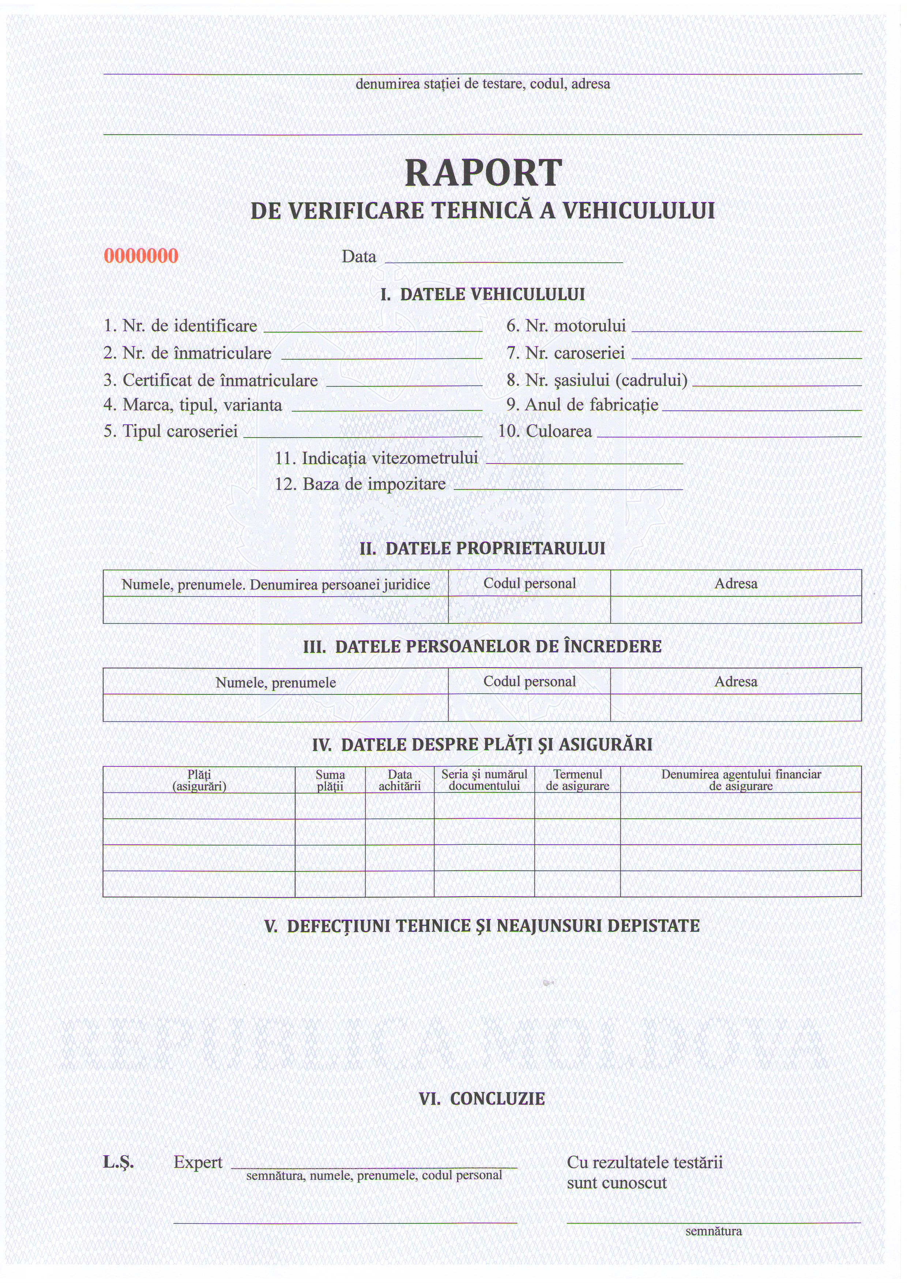
B. Notifications by the Netherlands

C. Notification by the Russian Federation

* * In accordance with the programme of work of the Inland Transport Committee for 2006–2010 (ECE/TRANS/166/Add.1, programme activity 02.4), the World Forum will develop, harmonize and update Regulations in order to enhance the performance of vehicles. The present document is submitted in conformity with that mandate.
? Application of Regulation No. 1 by Moldova, 3 February 2008. No depositary notification was created for this action because the Rule enters into force for all Contracting Parties to the Agreement which did not notify their disagreement thereto, in accordance with 2 (3). The date listed under "Application of rule" reflects the date of the entry into force of the Rule for those States parties to the Agreement, at the time of the entry into force of the Rule, which did not notify their disagreement thereto, in accordance with article 2(3) of the Agreement.

