Ek-1

MINISTRY OF TRADE USER MANUAL OF VIRTUAL QUEUE WITH BOOKING SYSTEM WEB/KIOSK APPLICATION

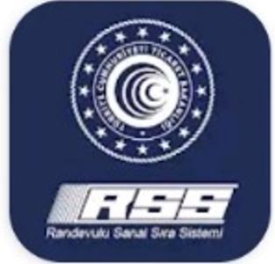

17 July 2020
General Directorate of Risk Management, Liquidation and Floating Capital
MOBILE APPLICATION OF VIRTUAL QUEUE SYSTEM WITH BOOKING (RSSS) WEB/KIOSK APPLICATION
(Application Steps)
1 | From your computer, visit the https://rsstest.ticaret.gov.tr web address and create the user registry. During registry please keep your identity number and your active mobile phone with you for sms verification. | 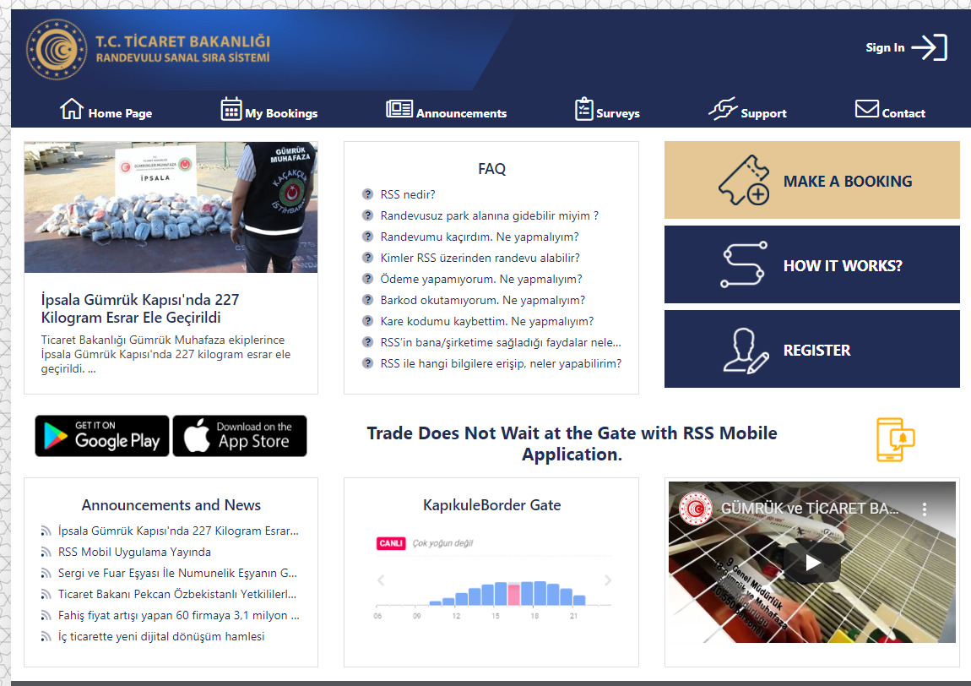
2 | Login with your user information.  (Turkish citizens shall login with Turkish ID Number (TCKN), Foreign nationals shall login with Passport Number.) | 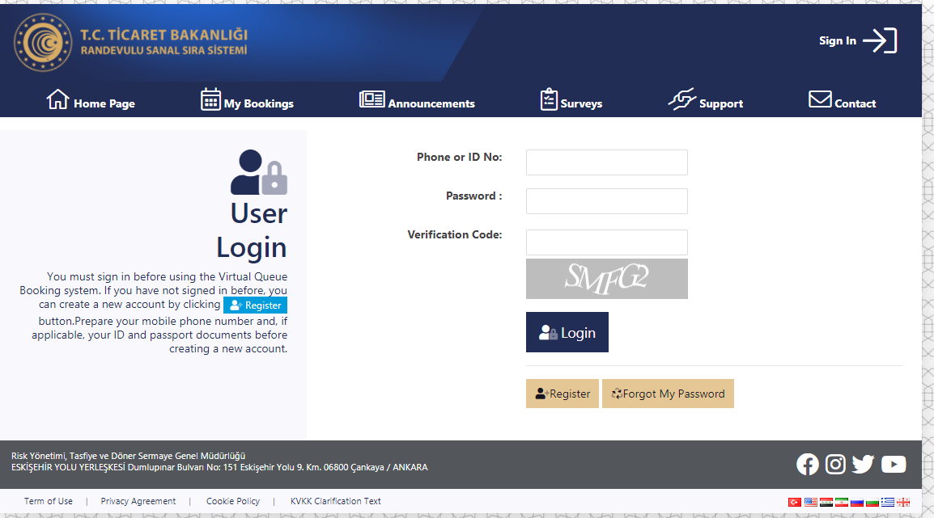
3 | Click to “Make a Booking” button and select the load information of your vehicle | 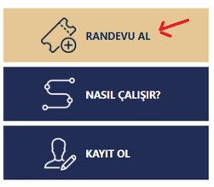
4 | Select load information of your vehicle as ful lor empty. Besides, enter the transport document type and document number correctly in compliance withthe BİLGE application. | 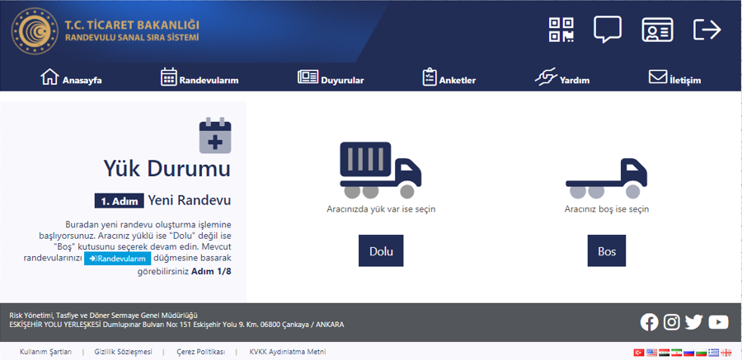
 |  | 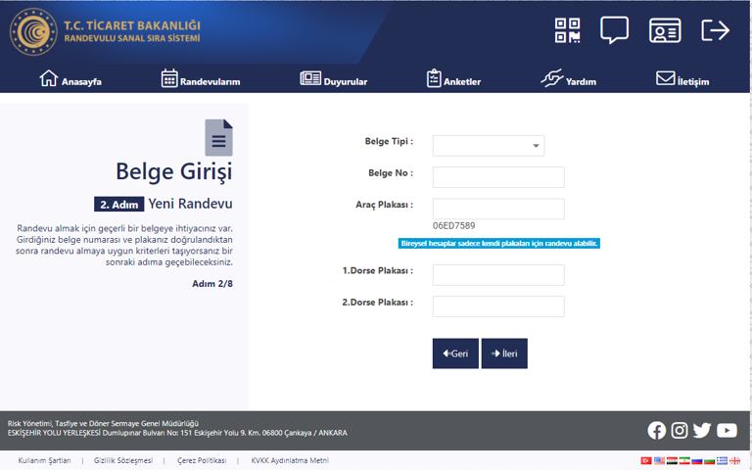
5 | Select the relevant options related with your load type/or any special circumstance about your status if there is any | 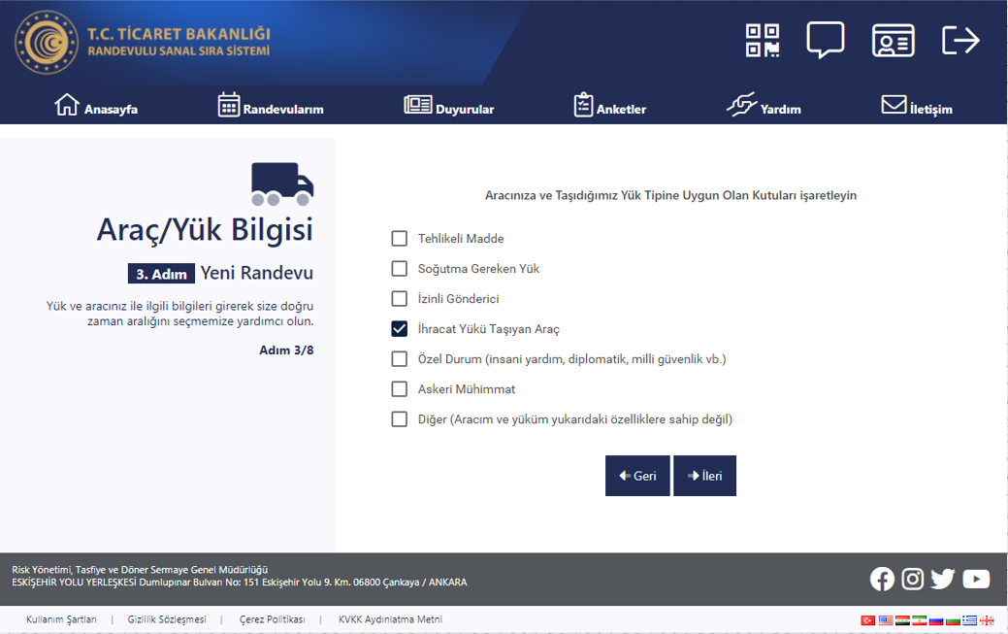
6 | Select the date that you are planning to exit the border and exact time that you will arrive to GTİ TIR Park. | 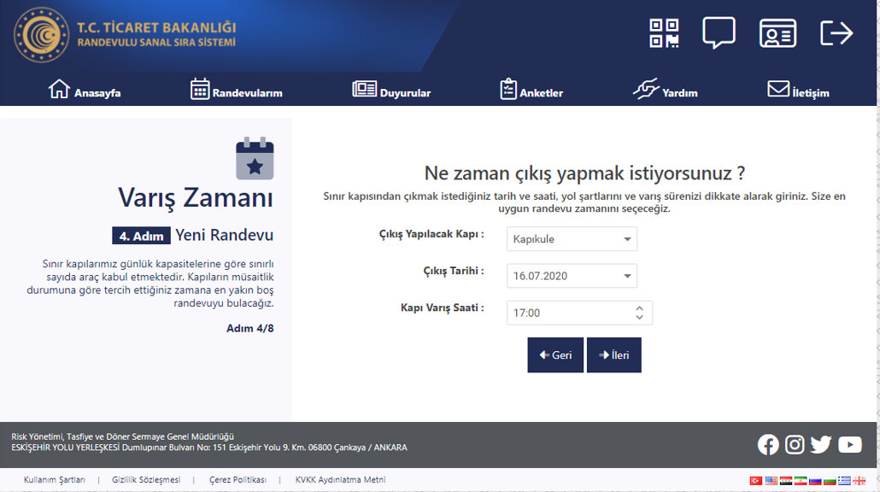
7 | There are time hourly slots in the system that state time intervals you estimate when to arrive to TIR Park and when to exit to the customs area (such as 14.00-15.00, 17.00-18.00). If the time interval which system assigned to you is suitable for you press the “Accept” button and enter the driver information.if not suitable press to “Change Date” button and select a suitable time interval (slot) for you. | 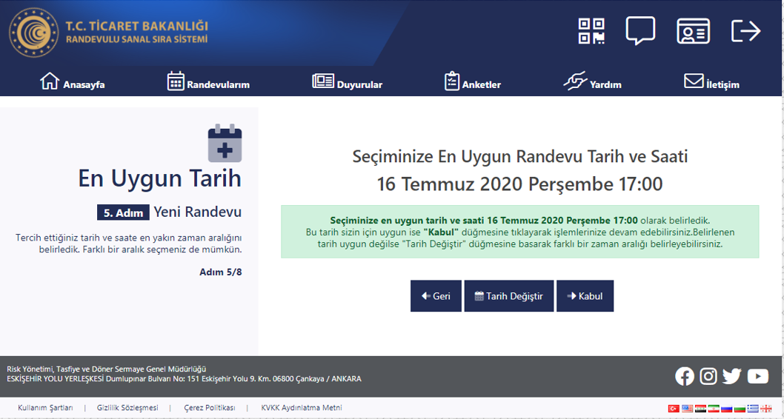
8 | Wait for SMS including the “digital ticket” link to your mobile phone. | 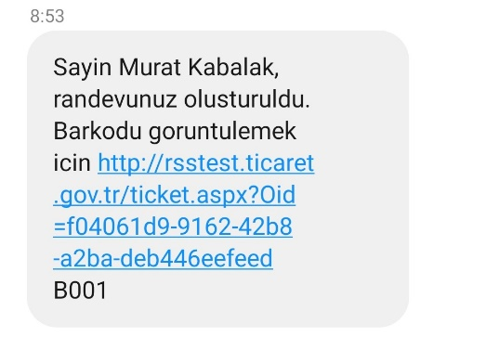
9 | Start driving forward to GTİ TIR Park.
10 | Your booking time is the time that you enter to GTİ Park. Please stick to this time. (For example; if 17.00-18.00 slot is selected, 17.00 is the time to enter to GTİ TIR Park, 18.00 is exit time from GTİ TIR Park.)
11 | When you arrive to GTİ TIR Park entrence, click to the “digital ticket” link in your mobile. | 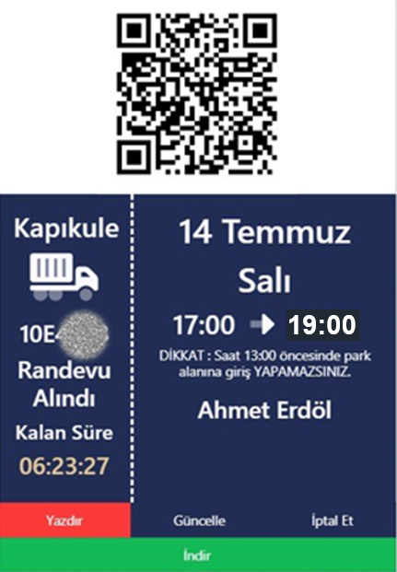
12 | Scan the QR Code displayed at the mobile application to the entry control unit. If you have arrived in compliance with your booking time barrier will be opened. After this stage, “Ready to Exit” button will be activated.
13 | Inside the GTİ TIR Park, make a notification that you are ready to exit by clicking to “Ready for Exit” button in your mobile application, digital ticket or kiosks. | 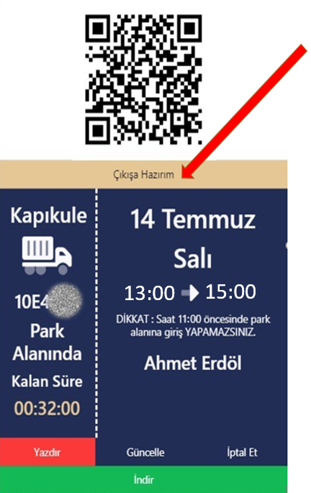
14 | Scan the QR code that you used to enter to the exit control unit. Move forward to the customs area when the barrier is opened.

